MATLAB installation guide for Wenzhou-Kean University

Wenzhou-Kean University provides MATLAB Campus-Wide License for all faculty members and students in campus. All faculty members and students can deploy products of MathWorks in both English and Chinese version on on-campus or personal computers. MATLAB Campus-Wide License contains Individual and Concurrent license. Individual license is used for the installation on personal computers (offline workable). Concurrent license is used for the installation on-campus computing facilities in computer labs or cluster.

Preparation and precautions before software installation:
- Ensure the computer installed MATLAB meets the minimum hardware configuration and system requirements which you can refer to below link:
https://mathworks.com/support/sysreq.html
- Please turn off system firewall before installing software.
- End user with Individual license need to reactivate the license at one specific intervals. After license expiration, it will automatically connect to MathWorks server. If the user is still a valid university faculty member or student, the user only needs to click ‘OK’ when the activation alert appears.


Scan the QR code with WeChat to check the installation guide and learning resource.

Go to MATLAB portal of Wenzhou-Kean University:
http://www.mathworks.com/academia/tah-portal/wenzhou-kean-university-31579530

- Installation guide for Individual License

- Register a MathWorks account
Visit webpage of account registration: https://www.mathworks.com/mwaccount/register
Then Complete account profile information. Please make sure enter the Email Address with university email address (email suffix includes @wku.edu.cn). For the ‘How will you use MathWorks software?’, faculty members and students select ‘Teacher/researcher in academia’ and ‘Student’ respectively
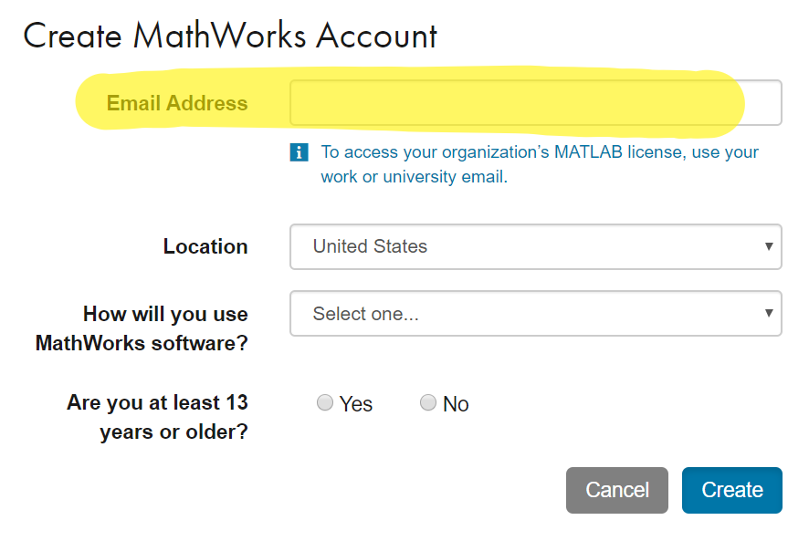
MathWorks will automatically send a verification mail to the email address. Please open the mail in the mail inbox. Click the button of ‘Verify your email’ (Note: If the verification mail can’t be found in the inbox, please check from the spam box). Then enter personal information in the profile creating page. Click ‘Create’ and keep the password.

- Software download
Please obtain the installation media from the following downloads. Installation media obtained by other means can’t be verified of its legality, which may result in inactivation and network security risks to your computer.
- Campus high speed download link:
<Campus Download address>
Then select installation media of required computer operating system. Campus high speed download is recommended.
- Download link for up-to-date or historical versions of MATLAB outside university:
https://www.mathworks.com/downloads

- Start the installer
The installation process is slightly different for different computer operating systems
- Windows: Unzip ISO and then click ‘setup.exe’
- MacOS: Double click ‘InstallForMacOSX.app’
- Linux: Execute setup commands ‘./install’

- Sign in to your MathWorks account
Please enter your MathWorks account name and password with university email address of Wenzhou-Kean University (email suffix includes @wku.edu.cn).
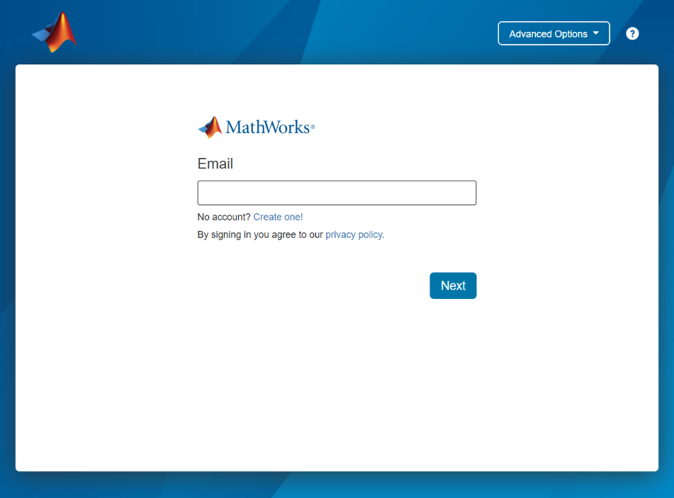

- MathWorks License Agreement
Select ‘Yes’ following ‘Do you accept the terms of license agreement?’. Then click ‘Next’.

- Select license
Select the associated license with label as ‘Individual’ in the list. Then click ‘Next’.
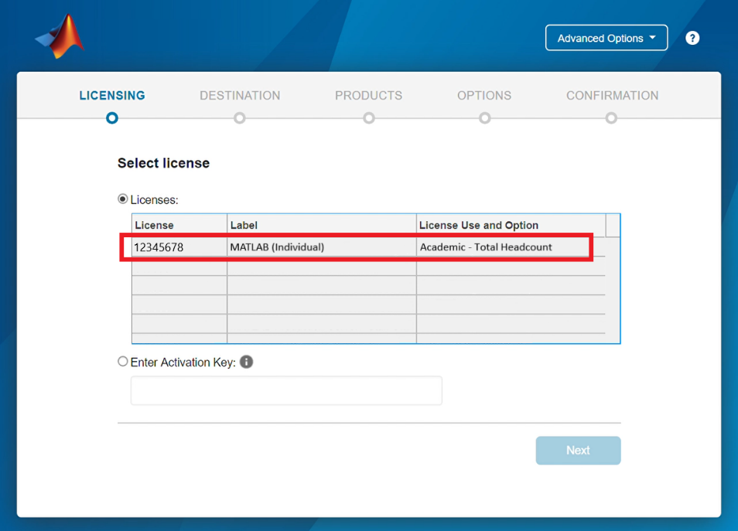

- Choose an authentication option
Select ‘Authorize this computer now’, then click ‘Next’.
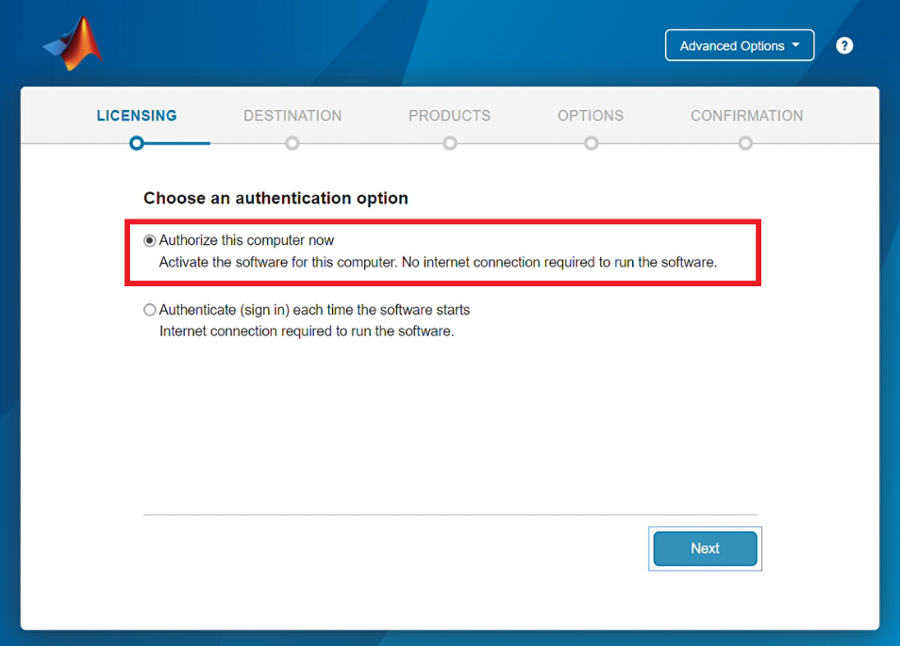

- Confirm User
Click ‘Next’ after confirming the user information is correct.

- Select destination folder
Generally, the default folder is recommended for installation. Then click ‘Next’.

- Select products
Select the products and toolbox needed or all of them. Then click ‘Next’.

- Select options
Ticking the option of ‘Add short to desktop’ is recommended. Then click ‘Next’.
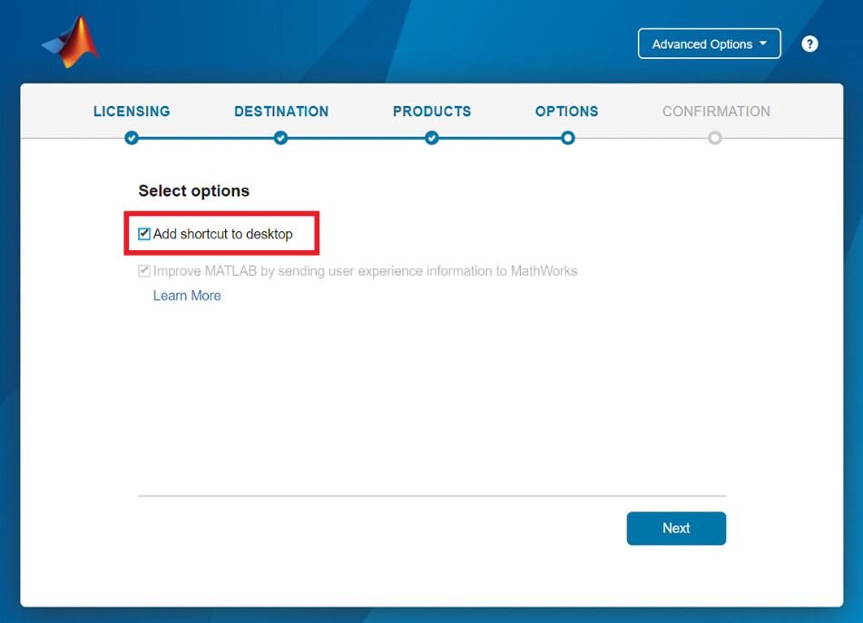

- Confirm selections
After confirming that the installation information is correct, click ‘Begin Install’ until the installation is complete.

- Installation guide for Concurrent License
Concurrent license is used for the installation on-campus computing facilities in computer labs or cluster. For further information, please contact WKU Library: library@wku.edu.cn

- MATLAB and Simulink learning resource
Free interactive MATLAB and Simulink tutorials are available to help students and other new users get started.
- MATLAB Onramp (120 mins – Login required)
- Simulink Onramp (180 mins – R2019a required)
- Machine Learning Onramp (120 mins – Login required)
- Deep Learning Onramp (120 mins – Login required)
- Reinforcement Learning Onramp (120 mins – Login required)
- Image Processing Onramp (120 mins – Login required)
- Signal Processing Onramp (120 mins – Login required)
- Simscape Onramp (120 mins – Login required)
- Stateflow Onramp (180 mins – Login required)
- Control Design Onramp with Simulink (120 mins – Login required)
- Optimization Onramp (60 mins – Login required)
- 11 MATLAB Advanced Courses (Login required)
- MATLAB Online (Access MATLAB via Web Browser)
- Recorded Webinar and Video (Learn MATLAB & Simulink through video)
- MATLAB Demo and Example (Contains abundant examples for teaching and research)

Please refer to the file, ’MATLAB Learning Resources’, for full learning and teaching resources.
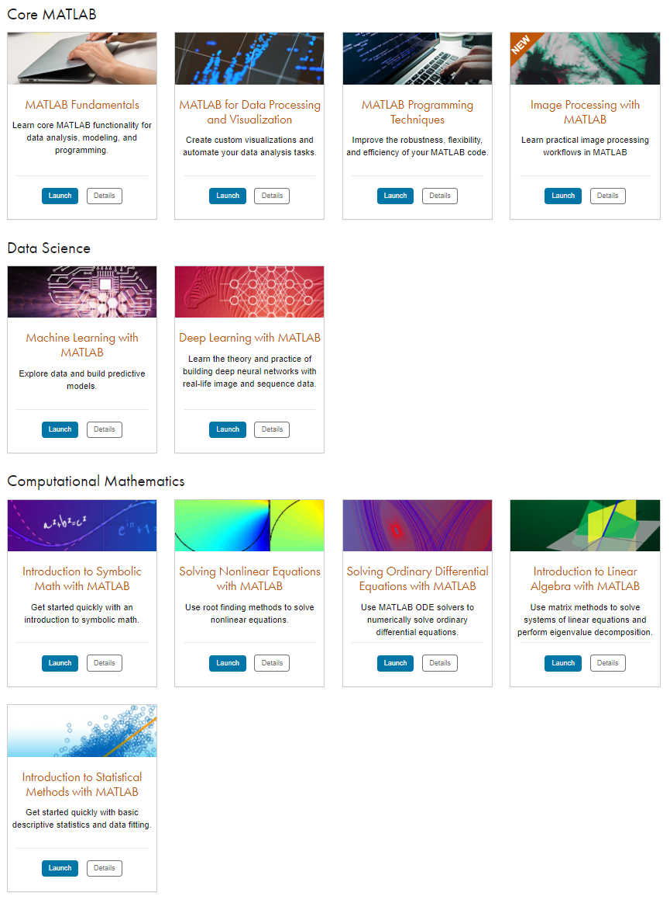

- Customer Support
If you have installation problems or other problems, you can get help in the following ways:

- Contact MathWorks customer support via email:
Installation problem: info@mathworks.cn
Technical problem: support@mathworks.cn
- Contact MathWorks customer support via phone:
010-59827000
- Submit your questions online (Log in with your MathWorks account):

https://www.mathworks.com/support/contact_us
Then click ‘Create Service Request’.
- Submit your questions in MATLAB:
Open MATLAB, then click ‘Request Support’ on the upper-right.
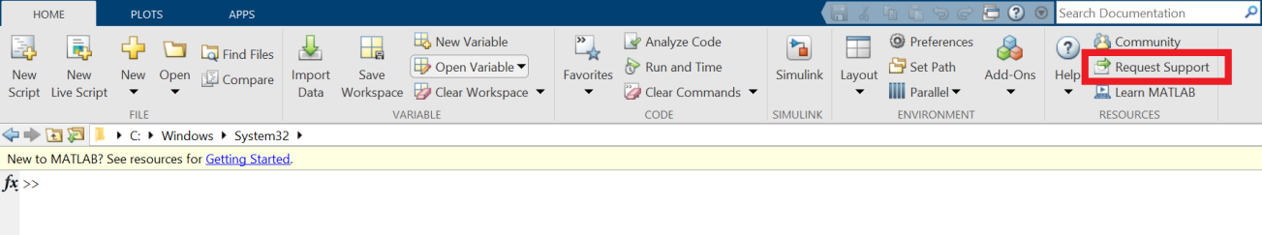
- Internal support of Wenzhou-Kean University:
Email: library@wku.edu.cn

