Step 1:

* 1. Go to: <https://wku.edu.cn/en/library/>;
  2. Search the keywords you need;

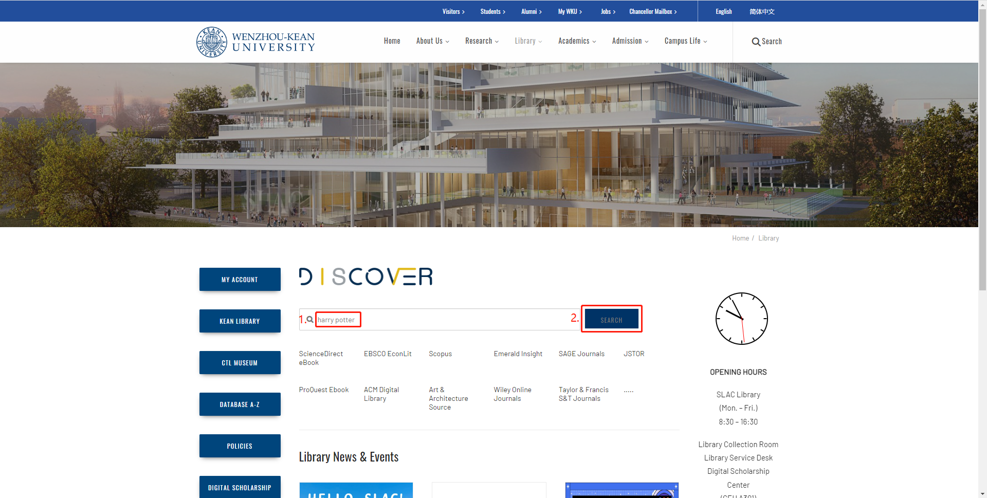

Step 2:

Log in to your WKU account;

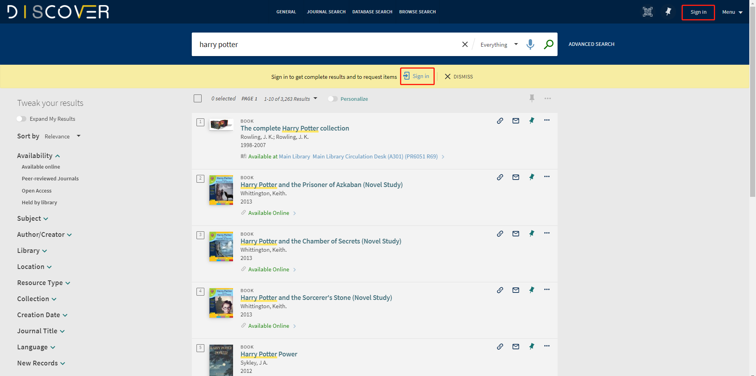

Step 3:   
Click "Available Online" and "Books.";

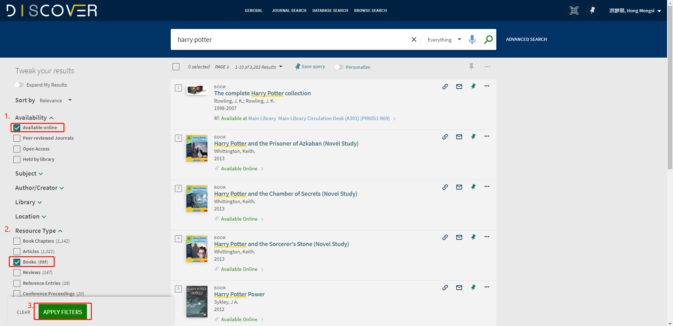

Step 4:

4.1 Choose the E-Books you need

4.2 Access the database of the E-books you need through the link provided under "View Online";

4.3 Follow the steps to read online or download them by chapter according to your actual needs.

4.2

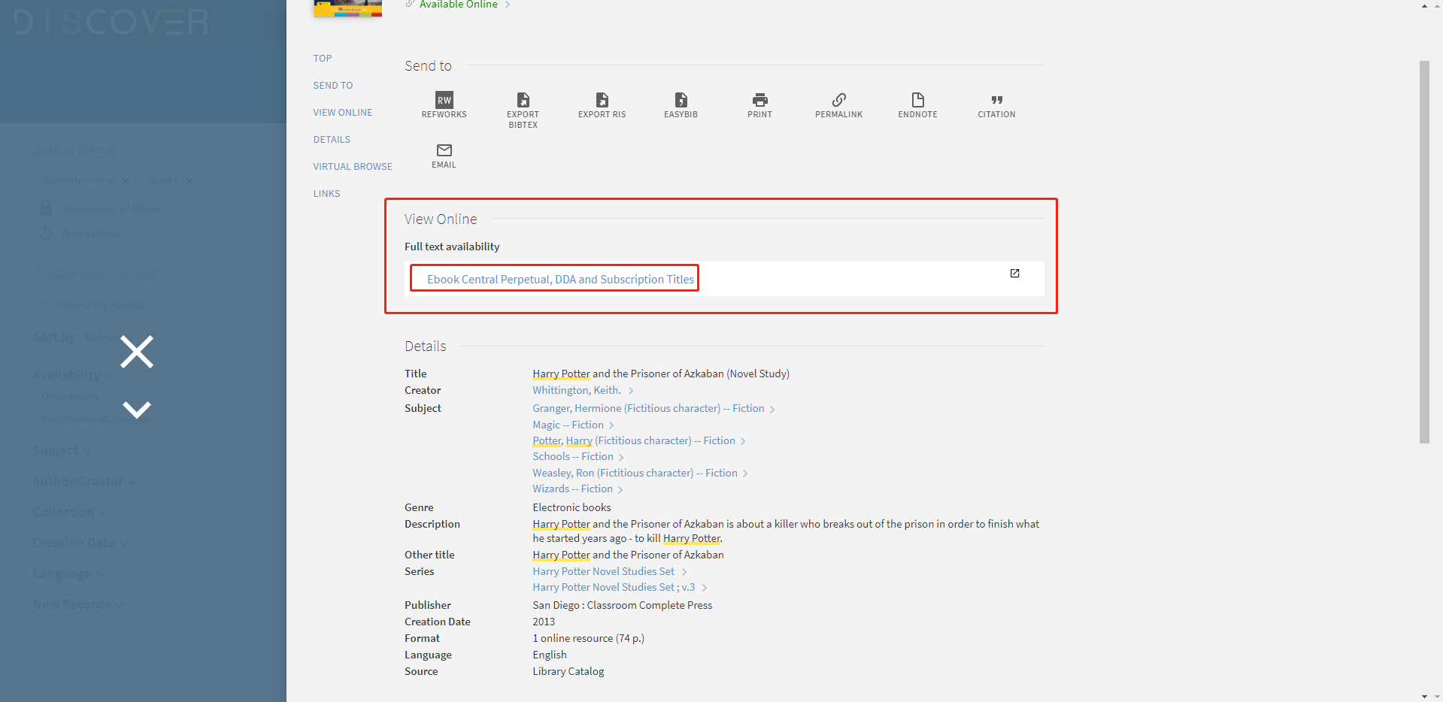

4.3

