Step 1：

Step 1: Enter in  
<https://wku.primo.exlibrisgroup.com.cn/discovery/search?query=any,contains,&tab=Everything&search_scope=MyInst_and_CI&vid=86WKU_INST:86wku&lang=en>;

Step 2:

Log in to your WKU account;

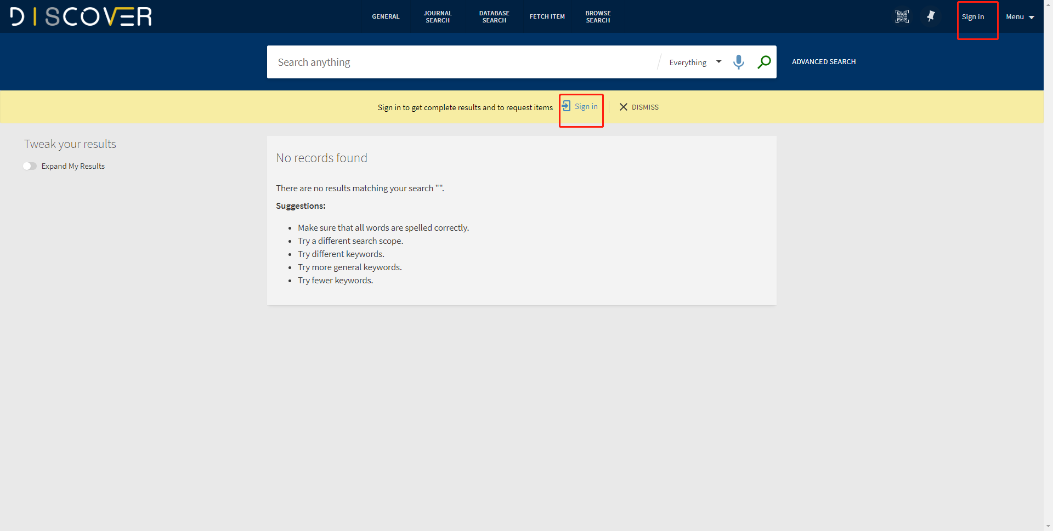

Step 3:   
Then click Journal Search;

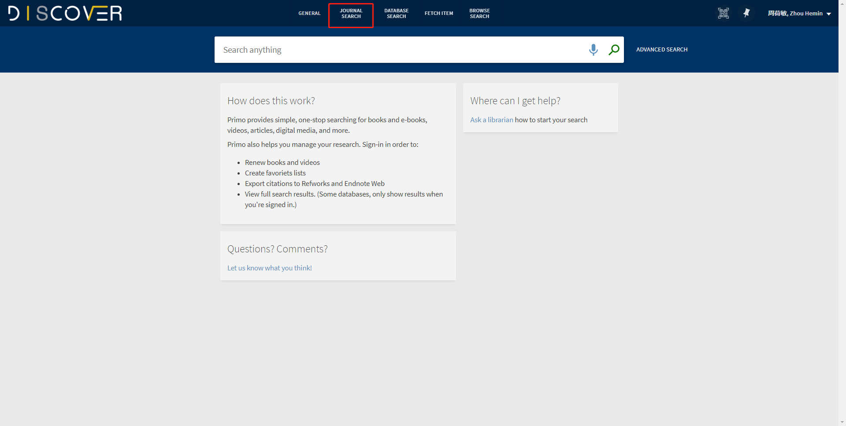

Step 4:   
1.1 Choose the E-Journals you need by selecting the category on the left navigation pal;

1.2 Search the keywords and choose the E-Journals you need;

2. Please enter the database of E-Journal you need through the link below the “View Online”;

1.1

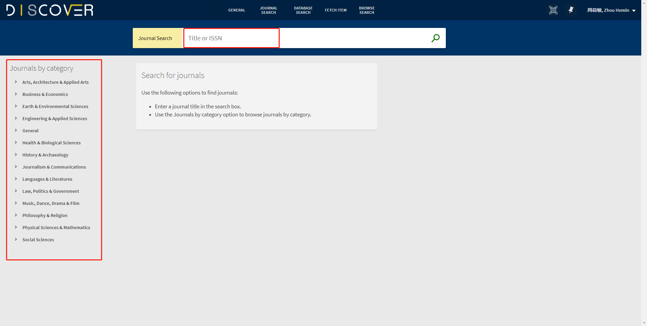

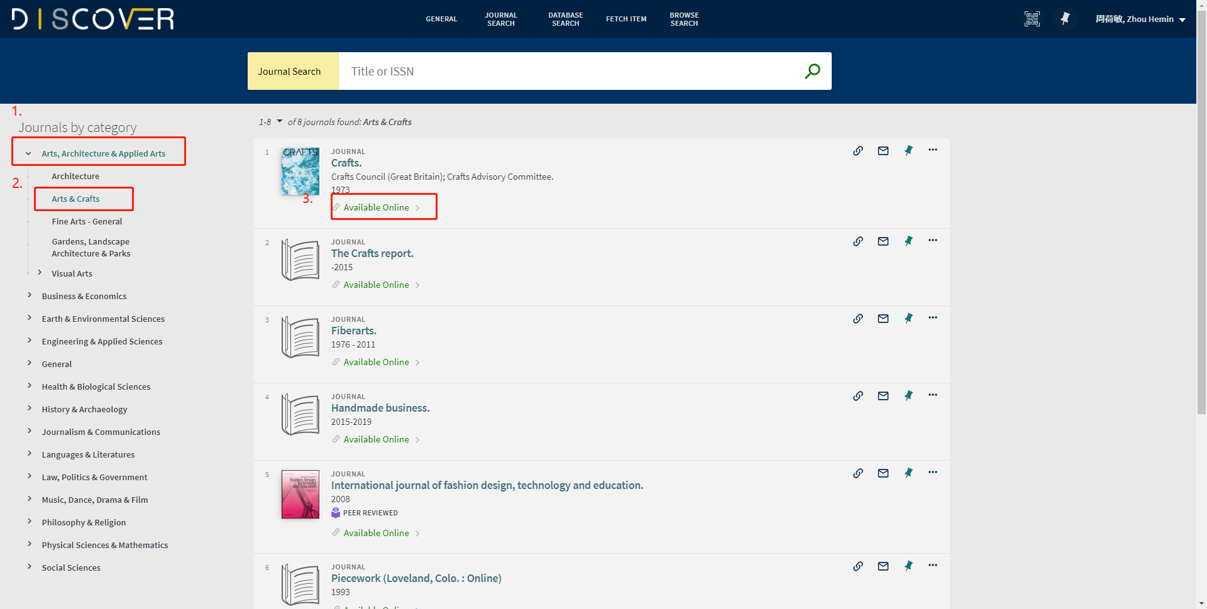

1.2

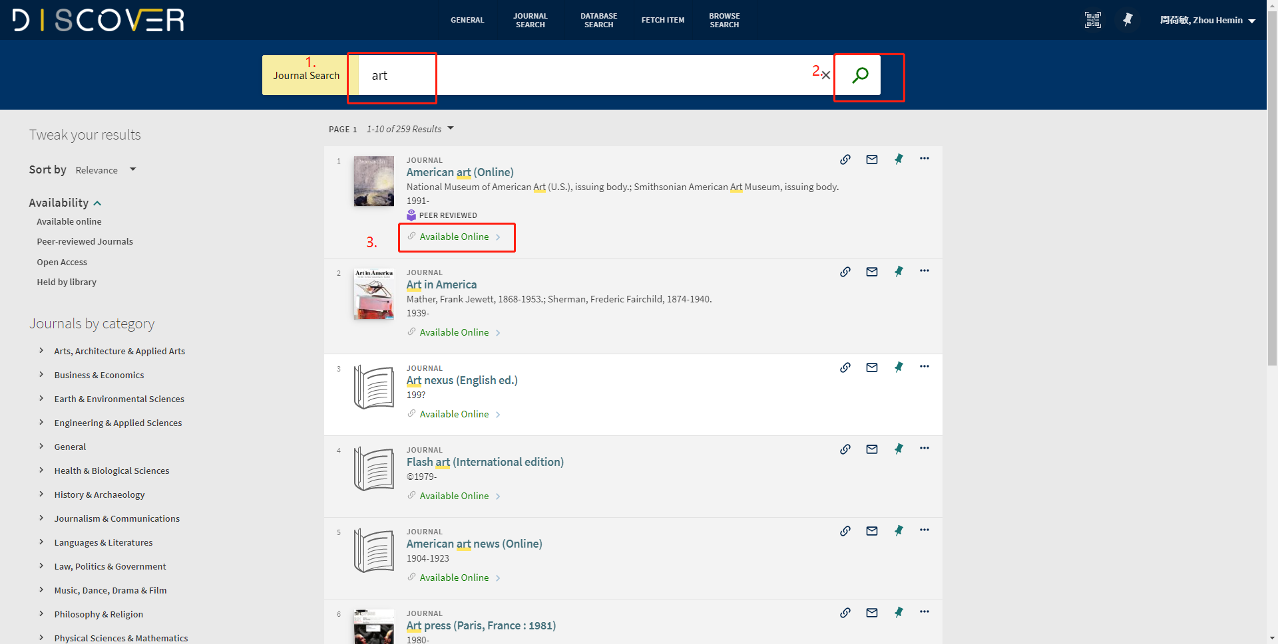

2.

