Step1:

Enter in: <http://wrds-web.wharton.upenn.edu>;

Step 2:

2.1 Click "Register" at the top of the page;

2.2 Please fill in the form with personal e-mail address with wku.edu.cn as the domain name, and choose Wenzhou-Kean University as “Subscriber“;

2.3 Submit the form of Register for WRDS;

2.1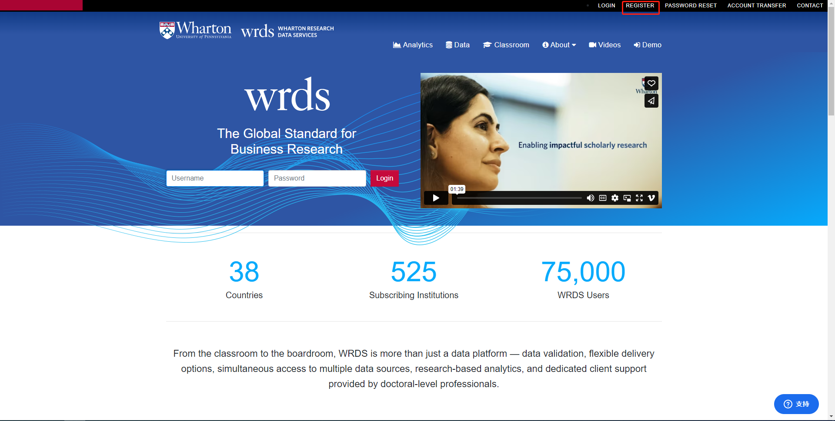

2.2

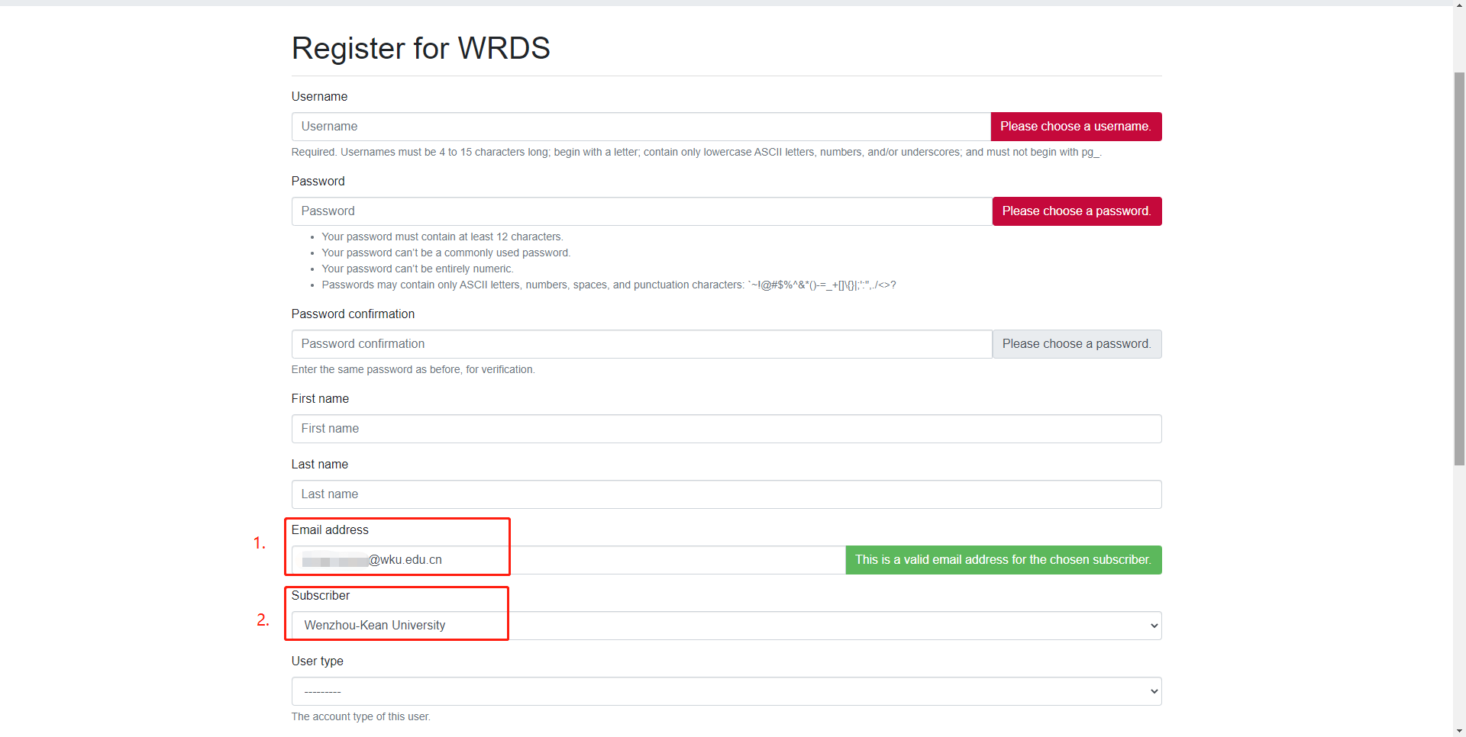

Step 3:

* 1. Follow the instructions to confirm your email address;
  2. After administrators approve your requests. You will receive another email once your WRDS account has be created;
  3. Login again and follow the steps to continue your enrollment;
  4. You can now access the data to which Wenzhou-Kean University is subscribed.

3.1

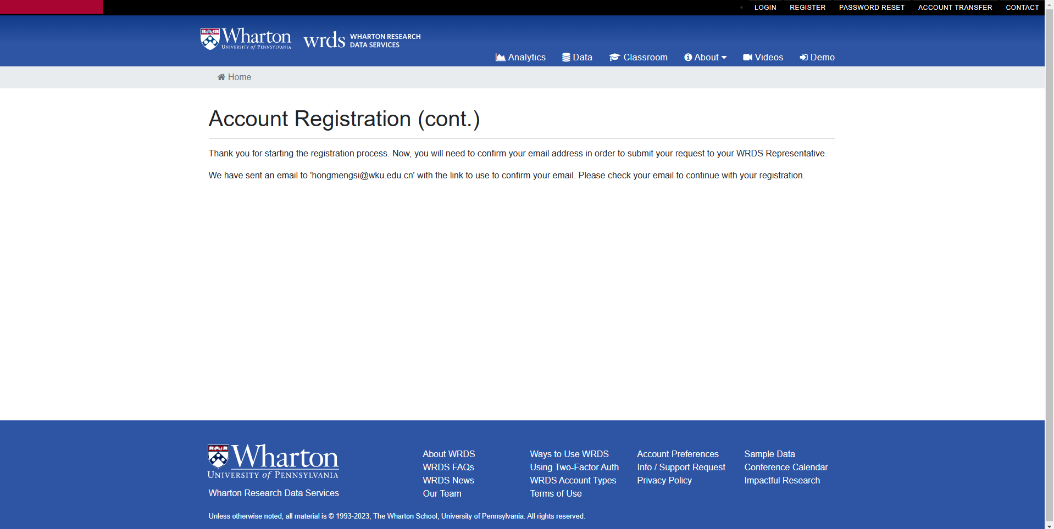

3.3

